SOAL ANALOG BAB 8
- For the network of Fig. 8.64:
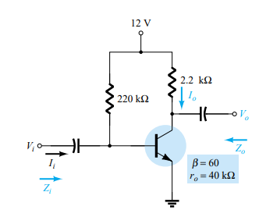
- Determine Zi and Zo
- re : IB = $\frac{Vcc-VBE}{RB}$ = $\frac{12 V - 0.7 V}{220K Ω}$ = 51.36 µA
IE = ( ß + 1 ) IB = (60 + 1)(51.36 µA) = 3.13 mA
re = $\frac{26 mV}{IE}$ = $\frac{26 mV}{3.31 mA}$ = 8.31 Ω
Zi = RB || ßre = 220K Ω || (60)(8.31 Ω) = 220K Ω || 498.6 Ω = 497.47 Ω
ro ≥ 10Rc * Zo = Rc = 2.2K Ω
- Find Av and Zo
- Av = - $\frac{Rc}{re}$ = $\frac{- 2.2K Ω}{8.31 Ω}$ = -264.74
Zo =
- Repeat part a with ro 20K Ω
- Zi = 497.47 Ω
Zo = ro || Rc = 20K Ω || 2.2K Ω = 1.98K Ω
- Repeat part b with ro 20K Ω
- Av = $\frac{-Rc ||ro}{re}$ = $\frac{-1.98K Ω}{8.31 Ω}$ = -238.27

- For the network of Fig 8.65 determine Vcc for a voltage gain of Av = -200
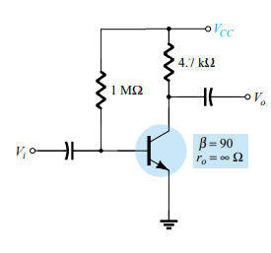
- Av = - $\frac{Rc}{re}$ re = - $\frac{Rc}{Av}$ = - $\frac{4.7K Ω}{-200}$ = 23.5 Ω
re = $\frac{26 mV}{IE}$ IE = $\frac{26 mV}{re}$ = $\frac{26 mV}{23.5 Ω}$ = 1.106 Ma
IB = $\frac{IE}{ß+1}$ = $\frac{1.106 mA}{91}$ = 12.15 µA
IB = $\frac{Vcc-VBE}{RB}$
Vcc = IBRB + VBE = (12.15 µA)(1M Ω) + 0.7 V = 12.15 V + 0.7 V = 12.85 V

- For the network of Fig 8.66 :
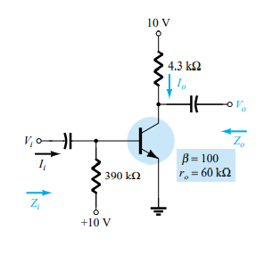
- Calculate IB, IC, and re
IB = $\frac{Vcc-VBE}{RB}$ = $\frac{10 V-0.7 V}{390K Ω}$ = 23.84 µA
IE = (ß+1)IB=(101)(23.84 µA) = 2.40 mA
re = $\frac{26 mV}{IE}$ = $\frac{26 mV}{1.89 mA}$ = 13.76 Ω
IC = ßIB = (100)(23.84 µA) = 2.384 mA
- Determine Zi and Zo
Zi = RB || ßre = 390K Ω || (100)(13.76 Ω) = 1.38K Ω
Ro ≥ 10Rc *Zo = Rc = 5.6K Ω
- Calculate Av and Ai
Av = - $\frac{Rc}{re}$ = $\frac{-5.6K Ω}{13.76 Ω}$ = -406.98
- Determine the effect of ro – 30K Ω and Av and Ai
Av = - $\frac{Rc ||r0}{re}$ = - $\frac{\left(5.6K Ω\right)||(30K Ω)}{13.76 Ω}$ = - $\frac{4.72K Ω}{13.76 Ω}$ = -343.03

- For the network of Fig 8.67 :
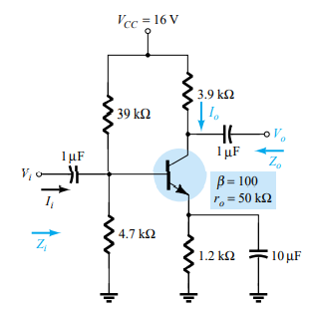
- Determine re
VB = $\frac{R2 VCC}{R1+R2}$ = $\frac{4.7K Ω (16 V)}{39K Ω+4.7K Ω}$ = 1.721 V
VE = VB-VBE = 1.721 V – 0.7 V = 1.021 V
IE = $\frac{VE}{RE}$ = $\frac{1.021 V}{1,2K Ω}$ = 0.8507 mA
re = $\frac{26 mV}{IE}$ = $\frac{26 mV}{0.8507 mA}$ = 30.56 Ω
- Calculate Zi and Zo
Zi = R1 || R2 || ßre
= 4.7K Ω ||39K Ω || (100)930.56 Ω) = 1.77K Ω
ro ≥ 10Rc *Zo = Rc = 3.9K Ω
- Find Av and Ai
Av = - $\frac{Rc}{re}$ = - $\frac{3.9K Ω}{30.56 Ω}$ = -127.6
- Repeat parts (b) and (c) with ro = 25K Ω
Zi = 1.77K
Zo = Rc || ro = 3.9K Ω || 25K Ω = 3.37K Ω
Av = - $\frac{(Rc ||r0)}{re}$ = - $\frac{\left(3.9K Ω\right)||(25K Ω)}{30.56 Ω}$ = - $\frac{3.37K Ω}{30.56 Ω}$ = -110.28

- Determine Vcc for the network of Fig. 8.68 if Av = -160 and ro = 100K Ω
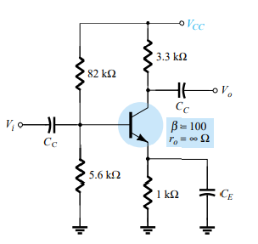
Av = = - $\frac{Rc}{re}$ = re = = - $\frac{Rc}{Av}$ = = - $\frac{3.3K Ω}{-160}$ = 20.625 Ω
re = $\frac{26 mV}{IE}$ = IE = = - $\frac{26 mV}{re}$ = $\frac{26 mV}{20.625 Ω}$ = 1.261 mA
IE = $\frac{VE}{RE}$ = VE =IERE = (1.261 mA)(1K Ω) = 1.261 V
VB = VBE + VE = 0.7 V + 1.261 V = 1.961 V
VB = $\frac{5.6K Ω VCC}{5.6K Ω+82K Ω}$ = 1.961 V
5.6K Ω VCC = (1.961 V)(87.6K Ω)
VCC = 30.68 V

- For the network of fig 8.69
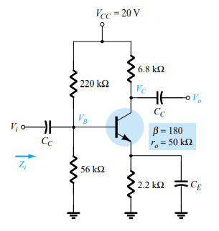
- Determine re
Rth = 56K Ω || 220K Ω = 44.64K Ω
Eth = $\frac{56K Ω (20 V)}{220K Ω+56K Ω}$ = 4.058 V
IB = $\frac{Eth-VBE}{Rth+\left(ß+1\right)RE}$ = $\frac{4.058 V-0.7 V}{44.64K Ω+(181)(2.2K Ω)}$ = 7.58 µA
IE = (ß + 1)IB = (181)(7.58 µA) = 1.372 mA
re = $\frac{26 mV}{IE}$ = $\frac{26 mV}{1.372 mA}$ = 18.95 Ω
- Calculate Vb and Vc
VE = IERE=(1.372 mA)(2.2K Ω) = 3.02 V
VB = VE + VBE = 3.02 V + 0.7 V = 3.72 V
VC = VCC – ICRC = 20V – ßIBRC = 20 V – (180)(7.58 µA)(4.7K Ω) = 13.59 V
- Determine Zi and Av = V0/Vi
Zi = R1 || R2 || ßre
= 56K Ω || 220K Ω || (180)(7.58 µA) = 44.64K Ω || 3.14K Ω = 3.17K Ω
ro < 10Rc
33.33K Ω < 10(4.7K Ω) = 47K Ω
Av = - $\frac{Rc ||r0}{re}$ = - $\frac{\left(6.8K Ω\right)||(50K Ω)}{18.95 Ω}$ = -298.15

- For the network of Fig 8.70
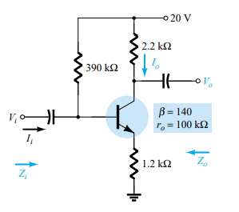
- Determine re
- Find Zi and Zo
- Calculate Av and Ai
- Repeat parts b and c with ro = 20K Ω

8. For the network of Fig. 8.71, determine RE and RB if Av 10 and re 3.8 . Assume that
Zb RE.
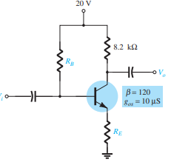
Jawabannya
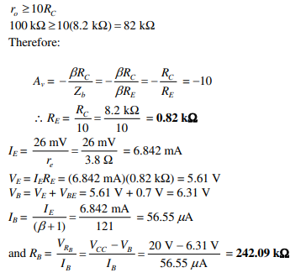
9. Repeat Problem 7 with RE bypassed. Compare results.
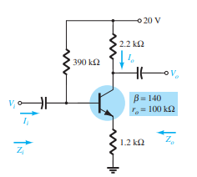

Jawabannya
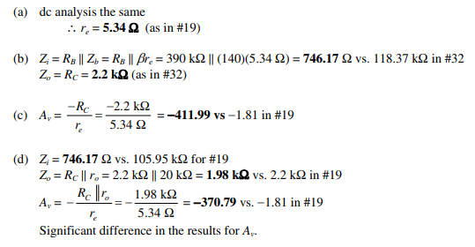
10. . For the network of Fig. 8.72:
(a) Determine re.
(b) Find Zi and Av.
(c) Calculate Ai.
Jawabannya
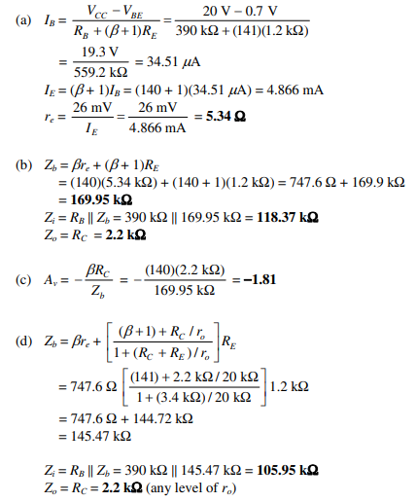
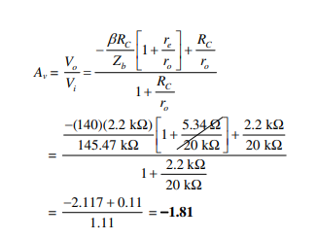
11. For the network of Fig. 8.73:
(a) Determine re and re.
(b) Find Zi and Zo.
(c) Calculate Av and A
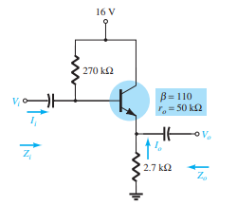
Jawabanya
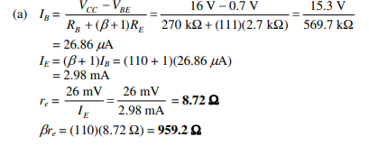
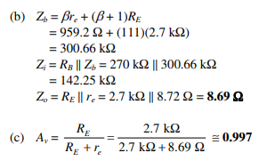
12. For the network of Fig. 8.74:
(a) Determine Zi and Zo.
(b) Find Av.
(c) Calculate Vo if Vi 1 mV.
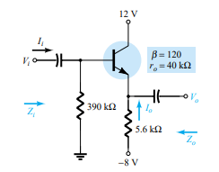
Jawabannya
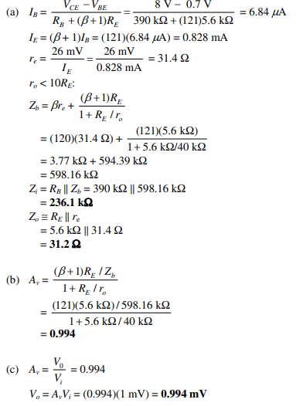
13. . For the network of Fig. 8.75:
(a) Calculate IB and IC.
(b) Determine re.
(c) Determine Zi and Zo.
(d) Find Av and Ai.
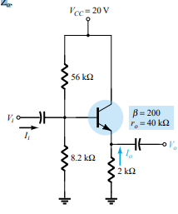
Jawabannya
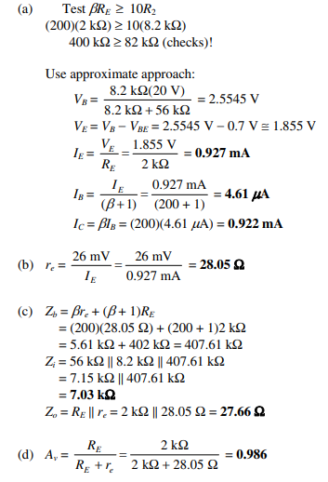
14. For the common-base configuration of Fig. 8.76:
(a) Determine re.
(b) Find Zi and Zo.
(c) Calculate Av and Ai.
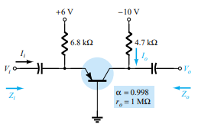
Jawabannya
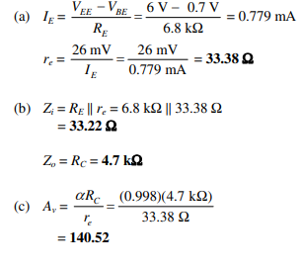
15. . For the network of Fig. 8.77, determine Av and Ai.
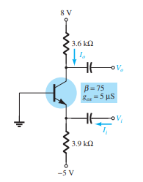
Jawabannya
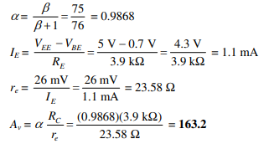

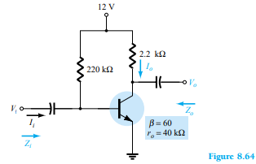
For the network of Fig. 8.64:
(a) Determine$Z_{i}$ and $Z_{o}.$
(b) Find $A_{v}$ and $A_{i}$
(c) Repeat part (a) with $r_{o}$ = 20 kΩ.
(d) Repeat part (b) with $r_{o}$ = 20 kΩ.

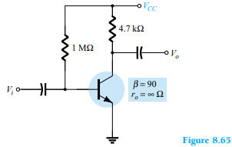
For the network of Fig. 8.65, determine $V_{CC}$for a voltage gain of $A_{v}$= - 200.

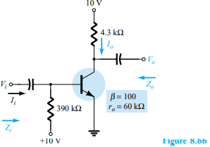
For the network of Fig. 8.66:
(a) Calculate $I_{B,}$ $I_{C,}$ $r_{e}$.
(b) Determine $Z_{i}$ and $Z_{o}.$
(c) Calculate $A_{v}$ and $A_{i}$
(d) Determine the effect of $r_{o}$ = 30 kΩ on $A_{v}$ and $A_{i}$.

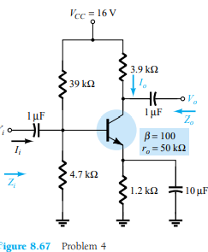
For the network of Fig. 8.67:
(a) Determine $r_{e}.$
(b) Calculate $Z_{i}$ and $Z_{o}.$
(c) Find $A_{v}$ and $A_{i}.$
(d) Repeat parts (b) and (c) with $r_{o}$ = 25 kΩ.

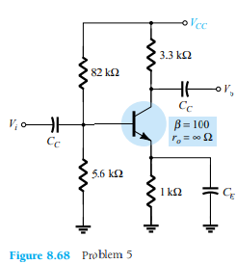
Determine $V_{CC}$for the network of Fig. 8.68 if $A_{v}= -160$and $r_{o}$ = 100 kΩ.

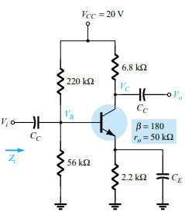
For the network of Fig. 8.69:
(a) Determine $r_{e}.$
(b) Calculate $V_{B}$ and $V_{C}.$
(c) Determine $Z_{i}$ and $A_{v}=$ $\frac{V_{o}}{V_{i}}$

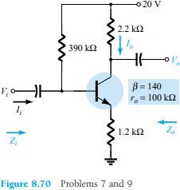
For the network of Fig. 870 :
(a) Determine$r_{e}.$
(b) Find $Z_{i}$ and $Z_{o}.$
(c) Calculate $A_{v}$ and $A_{i}.$
(d) Repeat parts (b) and (c) with $r_{o}$ = 20 kΩ.

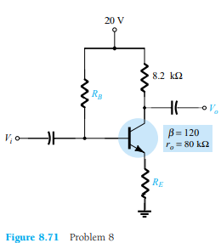
For the network of Fig. 8.71, determine $R_{E}$ and $R_{B}$ if $A_{v}= -$10 and $r_{e}=$3.8Ω. Assume that $Z_{b}= {βR}_{E}$.
- Repeat Problem 7 with $R_{E}$bypassed. Compare results.

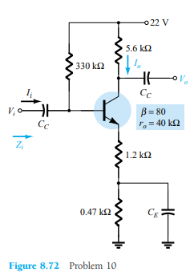
For the network of Fig. 872 :
(a) Determine$r_{e}.$
(b) Find $Z_{i}$ and $A_{v.}$
(c) Calculate $A_{i}.$

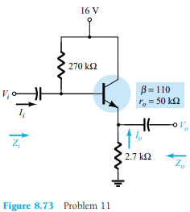
For the network of Fig. 873 :
(a) Determine$r_{e}$and ${βr}_{E}$.
(b) Find $Z_{i}$ and $Z_{o.}$
(c) Calculate $A_{v}$ and $A_{i}.$

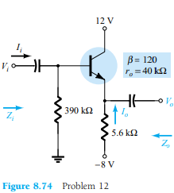
For the network of Fig. 874 :
(a) Determine$Z_{i}$ and $Z_{o.}$
(b) Find $A_{v.}$
(c) Calculate $V_{o}$ if $V_{i}$ = 1 mV.

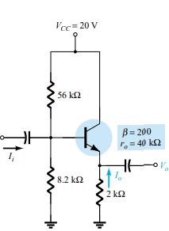
For the network of Fig. 875 :
(a) Calculate $I_{B}$ and $I_{C.}$
(b) Determine $r_{e.}$
(c) Determine$Z_{i}$ and $Z_{o.}$
(d) Find $A_{v}$ and $A_{i}.$

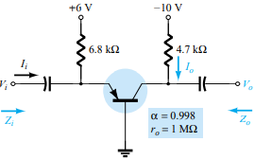
For the common-base configuration of Fig. 8.76:
- Determine $r_{e.}$
- Find$Z_{i}$ and $Z_{o.}$
- Calculate $A_{v}$ and $A_{i}.$

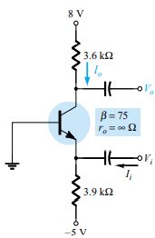
For the network of Fig. 8.77, determine $A_{v}$ and $A_{i}.$

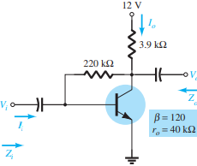
For the collector FB configuration of Fig. 8.78:
- Determine $r_{e}$
$I_{B}$ = $\frac{V_{CC}- V_{BE}}{R_{F}+ {βR}_{C}}= \frac{12 V-0.7 V}{220kΩ+120(3.9kΩ)}=16.42µA$
$$I_{E}=\left(β+1\right)I_{B}=\left(120+1\right)\left(16.42µA\right)=1.987mA$$
$$r_{e}= \frac{26 mV}{I_{E}}=\frac{26 mmV}{1.987mA}=13.08 Ω$$
- Find$Z_{i}$ and $Z_{o}$
$$Z_{i}= βr_{e}||\frac{R_{F}}{A_{v}}$$
$$A_{v}= \frac{-R_{C}}{r_{e}}=\frac{-3.9 kΩ}{13.08Ω}= -298$$
$Z_{i}=$ (120)(13.08Ω) || $\frac{220kΩ}{298}$ = $1.5696 kΩ||738Ω=501.98 Ω$
$Z_{o}= R_{C}$|| $R_{F}=3.9 kΩ$|| 220kΩ = 3.83 kΩ
- Calculate $A_{v}$ and $A_{i}$
From above, $A_{v}= -298$

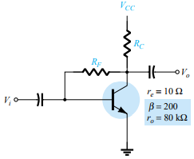
Given $r_{e.}$ = 10Ω, β = 200, $A_{v}$ = - 160, and $A_{i}$= 19 for the network of Fig. 8.79, determine $R_{C}, R_{F,}$ and $V_{CC.}$
$A_{v}= \frac{-R_{C}}{r_{e}}$ = - 160
$R_{C}=$ 160($r_{e}$) = 160(10Ω) = 1.6 kΩ
$A_{i}= \frac{βR_{F}}{R_{F}+ βR_{C}}=19→19= \frac{200R_{F}}{R_{F}+200(1.6 kΩ)}$ = $R_{F}=$ $\frac{3800R_{C}}{181}=\frac{3800(1.6 kΩ)}{181}=33.59$ kΩ
$I_{B}= \frac{V_{CC-V_{BE}}}{R_{F}+βR_{C}}= I_{B}\left(R_{F}+βR_{C}\right)= V_{CC-V_{BE}}$ and $V_{CC}= V_{BE}+ I_{B}\left(R_{F}+βR_{C}\right)$
with $I_{E}= \frac{26 mV}{r_{e}}= \frac{26 mV}{10Ω}=2.6 mA→ I_{B}= \frac{I_{E}}{β+1}= \frac{2.6mA}{200+1}=12.94 µA$
$$∴ V_{CC }= V_{BE}+I_{B}\left(R_{F}+βR_{C}\right)=0.7 V+\left(12.94 µA\right)\left(33.59 kΩ+\left(200\right)\left(1.6 kΩ\right)\right)=5.28 V$$
- For the network of Fig. 8.30:
- Derive the approximate equation for $A_{v.}$
$A_{v }: V_{i}= I_{b}βr_{e}$+ (β+1) $I_{b}R_{E}$
$I_{o}+ I^{'}= I_{C}= βI_{b}$, but $I_{i}= I^{'}+ I_{b}$ and $I^{'}= I_{i}-I_{b}$
Substituting, $I_{o}+\left(I_{i}- I_{b}\right)=βI_{b}$ and $I_{o}=\left(β+1\right)I_{b}-I_{i}$
Assuming $\left(β+1\right)I_{b}≫I_{i}$ $→$ $I_{o}≅ \left(β+1\right)I_{b}$ and $V_{o}= - I_{o} R_{C}= -\left(β+1\right)I_{b}R_{C}$
Therefore, $\frac{V_{o}}{V_{i}}=\frac{-\left(β+1\right)I_{b}R_{C}}{I_{b}{βR}_{E}+\left(β+1\right)I_{b}R_{E}}$ and $A_{v }=\frac{V_{o}}{V_{i}}≅ - \frac{R_{C}}{r_{e}+R_{E}}= -\frac{R_{C}}{R_{E}}$
(b) Derive the approximate equation for $A_{i}.$
(c) Derive the approximate equations for $Z_{i}$ and $Z_{o.}$
$V_{i}≅βI_{b}(r_{e}+R_{E})$ for $r_{e}≪R_{E}$ $→$ $V_{i}≅βI_{b}R_{E}$ $→$ Now $I_{i}+ I^{'}+ I_{b}= \frac{V_{i}-V_{o}}{R_{F}}$ + $I_{b}$
Since $V_{o}≫V_{i} →$ $I_{i}=-\frac{V_{o}}{R_{F}}+I_{b}$ or $I_{b}= I_{i}+\frac{V_{o}}{R_{F}}$ and $V_{i}=βR_{E}I_{i}+β\frac{V_{o}}{R_{F}}R_{E}$ but $V_{o}= A_{v}V_{i}$
and $V_{i}= βR_{E}I_{i}+\frac{βA_{v}V_{iR_{E}}}{R_{F}}$ or $V_{i}-\frac{A_{v}β_{R_{E}V_{i}}}{R_{F}}= βR_{E}I_{i}$ 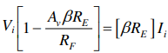
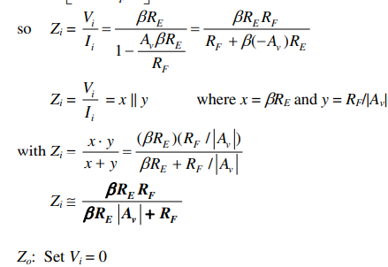
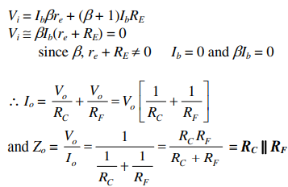
(d) Given $R_{C}$ = 2.2kΩ, $R_{F}$ = 120 kΩ, $R_{E}$ = 1.2 kΩ, β = 90, and $V_{CC}$ = 10 V, calculate the magnitudes of $A_{v}$, $A_{i}$, $Z_{i}$ and $Z_{o}$ using the equations of parts (a) through (c).
$A_{v }≅$ $-\frac{R_{C}}{R_{E}}$ = - $\frac{2.2kΩ}{1.2kΩ}= -1.83$
$Z_{i}≅\frac{{βR}_{E}R_{F}}{{βR}_{E}\left|A_{V}\right|+R_{F}}=\frac{\left(90\right)\left(1.2kΩ\right)\left(120kΩ\right)}{\left(90\right)\left(1.2kΩ\right)\left(1.83\right)+120kΩ}=$ 40.8 kΩ
$Z_{o}≅$ $R_{C}$|| $R_{F}=2.2kΩ||$120kΩ = 2.16 kΩ

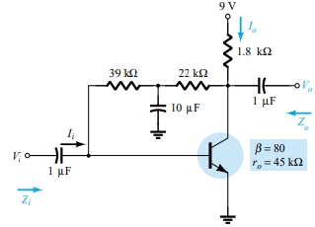
For the network of Fig. 8.80:
- Determine$Z_{i}$ and $Z_{o.}$
$$I_{B}=\frac{V_{CC}-V_{BE}}{R_{F}+{βR}_{C}}=\frac{9 V-0.7 V }{(39 kΩ+22kΩ)(80)(1.8 kΩ)}= \frac{8.3 v}{61 kΩ+144 kΩ}=\frac{8.3 V}{205 kΩ}=40.49 µA$$
$$I_{E}=\left(β+1\right)I_{B}=\left(80+1\right)\left(40.49 µA\right)=3.28 mA$$
$$r_{e}= \frac{26 mV}{I_{E}}=\frac{26 mV}{3.28 mA}=7.93 Ω$$
$Z_{i}= R_{Fi}$|| ${βr}_{e}=$39 k$Ω$ || (80)(7.93 $Ω$)= 39 k$Ω$ || 634.4 $Ω$ = 0.62 k$Ω$
$Z_{o}=$ $R_{C}$|| $R_{F2}=1.8 kΩ||$22 kΩ = 1.66 kΩ
- Find $A_{v}$ and $A_{i}.$
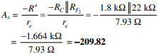
- (a) Given β = 120, $r_{e}$ = 4.5Ω and $r_{o}=$40kΩ, sketch the approximate hybrid equivalent circuit.
$h_{fe}=$ β = 120
$h_{ie}$ $≅$ β$r_{e}$ = (120)( 4.5Ω) = 540 Ω
$h_{oe}=$ $\frac{1}{r_{o}}= \frac{1}{40 kΩ}=25 µ$S
(b) Given $h_{ie}$= 1 kΩ, $h_{re}=2×{10}^{-4}, h_{fe}=90, and h_{oe}=20µS,$skecth the $r_{e}$ model.
$r_{e}≅$ $\frac{h_{ie}}{β}= \frac{1kΩ}{90}=11.11 Ω$
$β=$ $h_{fe}=90$
$r_{o}=$ $\frac{1}{h_{oe}}= \frac{1}{20 µS}=50 kΩ$
- For the network of Problem 1:
- Determine $r_{e}=8.31 Ω$
- $h_{fe}=$ β = 60
$h_{ie}$ $=$ β$r_{e}$ = (60)( 8.31 Ω) = 498.6 Ω
- Find $Z_{i}$ and $Z_{o.}$using the hybrid parameters.
$Z_{i}= R_{B}$|| $h_{ie}$ $=$ 220 kΩ || 498.6 Ω = 497.47 Ω
$Z_{o}=$ $R_{C}=2.2 kΩ$
- Calculate $A_{v}$ and $A_{i}$using the hybrid parameters.
$A_{v}= \frac{-h_{fe}R_{C}}{h_{ie}}= \frac{-(60)(2.2kΩ)}{498.6 Ω}$ = -264.74
$A_{i}≅h_{fe}=$ 60
- Determine$Z_{i}$ and $Z_{o}$ If $h_{oe}=$50 µS.
$$Z_{i}=497.47 Ω (the same)$$
$Z_{o}= r_{o}$|| $R_{C}, r_{o}$ = $\frac{1}{25 µS}=40 kΩ$ $→$ $40 kΩ$ || $2.2 kΩ$ = 2.09 $kΩ$
- Determine $A_{v}$ and $A_{i}$ If $h_{oe}=$50 µS.
$A_{v}= \frac{-h_{fe}{(r_{o}||R}_{C)}}{h_{ie}}= \frac{-(60)(2.085 kΩ)}{498.6 Ω}$ = -250.90
$$A_{i}= -\frac{A_{v}Z_{i}}{R_{C}}= -\frac{\left(-250.90\right)\left(497.47Ω\right)}{2.2 kΩ}=56.73$$
(g) Compare the solutions above with those of Problem 1. (Note: The solutions are available in Appendix E if Problem 1 was not performed.)

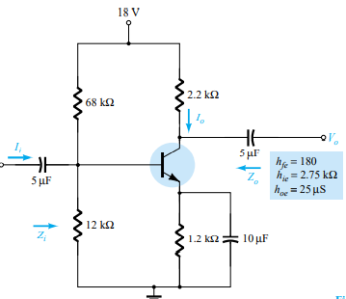
For the network of Fig. 8.81 :
- Determine$Z_{i}$ and $Z_{o.}$
68 kΩ || 12 kΩ = 10.2 kΩ
$Z_{i}$ = 10.2 kΩ || $h_{ie}$ = 10.2 kΩ || 2.75 kΩ = 2.166 kΩ
$Z_{O}$ = RC || $r_{o}$ = 2.2 kΩ || 40 kΩ = 2.085 kΩ
- Calculate $A_{v}$ and $A_{i}.$
$A_{v}= \frac{-h_{fe}{R'}_{C}}{h_{ie}}$ $→{R'}_{C}= R_{C }$|| $r_{o}=2.085 kΩ$
= $\frac{-(180)(2.085 kΩ)}{2.75 kΩ}$ = -136.5
$A_{i}=$ $\frac{I_{O}}{I_{i}}= \frac{I_{O}}{{I'}_{i}}$ $×$ $\frac{{I'}_{i}}{I_{i}}$ = 135.13
- Determine $r_{e}$and β$r_{e}$ to $h_{ie.}$

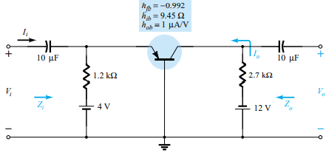
For the common-base network of Fig. 8.82:
- Deterime $Z_{i}$ = $R_{E}$ || $h_{ib}$ = 1.2 kΩ || 9.45 Ω = 9.38 Ω
$Z_{o}$ = $R_{C}$ || $\frac{1}{h_{ib}}=$2.7 kΩ || $\frac{1}{1×{10}^{-6}A/V}$ = 2.7 kΩ || 1 MΩ $≅$ 2.7 kΩ
- $A_{v}= \frac{{-h}_{fb}(R_{C} \frac{1}{h_{ab}})}{h_{ib}}= \frac{-(-0.992)(≅2.7 k)}{9.45 }=284.43$
$$A_{i}≅-1$$
- Determine α, β, $r_{e}$and $r_{o}$.
α = ${-h}_{fb}= -\left(-0.992\right)=0.992$
β = $\frac{α}{1-α}= \frac{0.992}{1-0.992}=124$
$$r_{e}=h_{ib}=9.45 Ω$$
$$r_{o}= \frac{1}{h_{ab}}= \frac{1}{1µA/V}=1 MΩ$$
- Repeat parts (a) and (b) of Problem 22 with $h_{re}=2×{10}^{-4}$ and compare results.

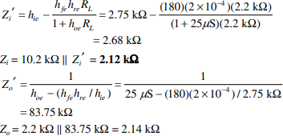

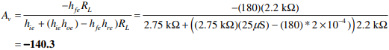

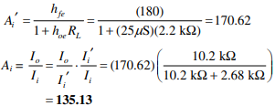

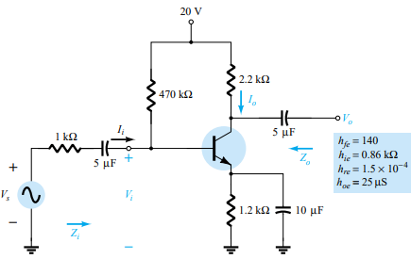
For the network of Fig. 8.83, determine:
- $Z_{i}^{'}= h_{ie}= \frac{h_{fe}h_{re}R_{L}}{1+h_{oe}R_{L}}=0.86kΩ-\frac{\left(140\right)\left(1.5x{10}^{-4}\right)\left(2.2kΩ\right)}{1+\left(25 µS\right)\left(2.2kΩ\right)}=0.86kΩ-43.79Ω=816.21 Ω$
$Z_{i}=R_{B}$||$Z_{i}^{'}=470 kΩ$ ||816.21 Ω = 814.8 Ω
- $A_{v}$ = $\frac{-h_{fe}R_{L}}{h_{ie}+\left(h_{ie}h_{oe}-h_{fe}h_{re}\right)R_{L}}=\frac{-\left(140\right)\left(2.2kΩ\right)}{0.86kΩ+\left(\left(0.86kΩ\right)\right)\left(25 µS\right)-(140)\left(1.5x{10}^{-4}\right))2.2kΩ}= -357.68$
- $A_{i}$ = $\frac{I_{O}}{I_{i}}=\frac{h_{fe}}{1+h_{oe}R_{L}}= \frac{140}{1+\left(25 µS\right)\left(2.2kΩ\right)}=132.70$
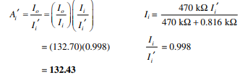
- $Z_{o}= \frac{1}{h_{oe}-(h_{fe}h{re}_{/}(h_{ie}+R_{s})}=\frac{1}{\left(25 µS\right)-((140)\left(1.5x{10}^{-4}\right))(0.86kΩ+1kΩ))}= \frac{1}{13.71µS}=72.9kΩ$

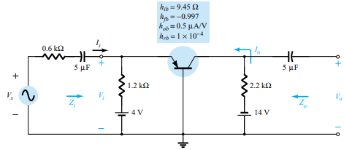
For the common-base amplifier of Fig. 8.84, determine:
- $Z_{i}^{'}=h_{ib}- \frac{h_{fb}h_{rb}R_{L}}{1+h_{ob}R_{L}}=9.45kΩ-\frac{\left(-0.997\right)\left(1x{10}^{-4}\right)\left(2.2kΩ\right)}{1+\left(0.5 µ\frac{A}{V}\right)\left(2.2kΩ\right)}=9.67Ω$
$Z_{i}=1.2 kΩ$||$Z_{i}^{'}=$ $1.2 kΩ$ ||9.67 Ω = 9.59 Ω
- $A_{i}^{'}=\frac{h_{fb}}{1+h_{ob}R_{L}}=\frac{0.997}{1+\left(0.5 µ\frac{A}{V}\right)\left(2.2kΩ\right)}=-0.996$
$A_{i}=\frac{I_{o}}{I_{i}^{'}}.\frac{I_{i}^{'}}{I_{i}}=(-0.996)\frac{1.2 kΩ}{1.2 kΩ+9.67 kΩ}$ = - 0.998
- $A_{v}=\frac{-h_{fL}R_{L}}{h_{ib}+\left(h_{ib}h_{ab}-h_{fb}h_{fb}\right)R_{L}}=\frac{-\left(-0.997\right)\left(2.2kΩ\right)}{9.45Ω+\left(\left(9.45Ω\right)\right)\left(0.5µA/V\right)-(0,997)\left(1x{10}^{-4}\right))2.2kΩ}= 226.21$
- $Z_{O}^{'}=\frac{1}{h_{ab}-\left[h_{fb}h_{rb}/h_{ib}\right]}=\frac{1}{\left(0.5µA/V\right)-((-0,997)\left(1x{10}^{-4}\right))/9.45 Ω}=90.5kΩ$
$Z_{o}$ = $2.2k$|| $Z_{O}^{'}$ = 2.15kΩ

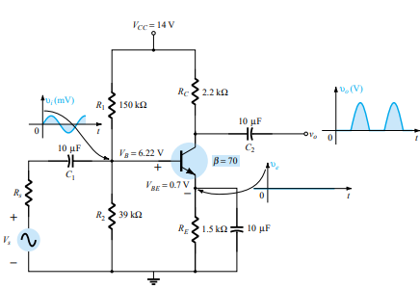
Given the network of Fig. 8.85:
- Determine if the system is operating properly based on the voltage-divider bias levels and expected waveforms for $V_{o}$ and $V_{E.}$
- Determine the reason for the dc levels obtained and why the waveform for $V_{o}$was obtained.
- Using PSpice Windows, determine the gain for the network of Fig. 8.6. Use Probe to display the input and output waveforms.
- Using PSpice Windows, determine the gain for the network of Fig. 8.13. Use Probe to display the input and output waveforms.
- Using PSpice Windows, determine the gain for the network of Fig. 8.25. Use Probe to display the input and output waveforms.

